

Keeping in Touch at SMUMCHH
Weekly Newsletter – Week of August 3

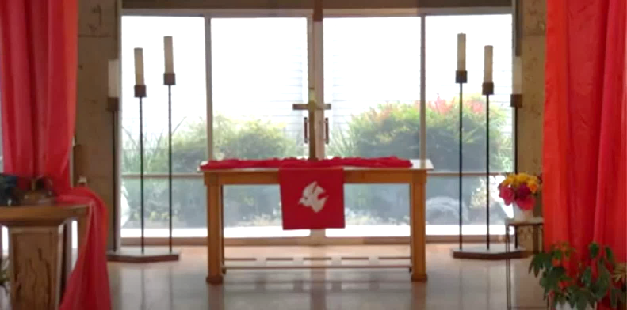


Let’s Worship Together!

8:00 a.m. Informal Service
10:00 a.m. Traditional Worship

IN OUR PRAYERS
Prayers:
Many prayers of peace and condolences to the families of those who were shot and
killed at a midtown Manhattan office building on Monday, July 28th. God surround you with His comfort, peace and love.
Prayers for Todd Peterson for a successful outcome for his outpatient surgery on Monday, August 4th, as well as for his quick rehab.
Continued prayers for all those in the USA affected by the current weather and natural disasters – the dangerous heat levels, floods, wildfires, tornados. Condolences to the families of those who have lost their lives in the storms. Prayers for all as they begin putting their lives back in order. Gratitude to all who help with the rescue efforts.
Compassion for those people living under the cloud of fear because of the color
of their skin.
Prayers that those who wish to protest - always remain to do so peacefully.
Prayers out into our World:
Prayers to end the violence against each other happening in our world.
Prayers to end our World’s hunger and starvation.
Prayers of peace and reconciliation for Iran, Israel, the USA, and all the people of our World who are or become involved in the current dispute.
Continued prayers for our Church Members, Church Family, and Friends:
Carlita Bongolan, Terry Feulner, Ted and Betty Williams, Ruth Feick, Jean Logan, Doris Sachs, Dorothy Tarvin, Frank Bouma (son of Ruth Barnes), Lisa (daughter of Orlen Willoughby), Chris Kozak (son of Rich and Denise Kozak), Diane Crawford (daughter of Shirley Butler), Jeff Graves (son of Joe and Patty Graves), Sharon Dutton (daughter of Ruth Barnes).
SUNDAY WORSHIP SERVICES VOLUNTEERS
August Liturgist Donna Peterson

If you would like to serve as a Liturgist, please see Olga Baker after worship or give her a call.

Coffee Fellowship Host & Hostesses

August 3 Rodney Kurimoto
August 10 Margaret Gow
August 17 The Robles Family
August 24 Alice and Eric Cheng
August 31 Pastor David and Mary Choi

If you would like to host our Coffee Fellowship Time after Worship on any Sunday, please contact or see Carol Rogers.

BIRTHDAYS AND WEDDING ANNIVERSARIES

August Birthdays August 1 Bob Holte
August 6 Carlita Bongolan
August 11 Marilee Hartling
August 15 Jean Shelby
August 23 Elias Robles
August 24 Steven Hill

August Wedding Anniversaries August 9 Mike & Chris Gallagher
August 17 Jerry & Eileen Casterline
August 24 Rick & Pat Kunishima
August 25 Richard & Diane Cline
ANNOUNCEMENTS

Adult Sunday School will NOT be getting together during the month of August.

Ongoing Outreach Project - “Hygiene Kits!” St. Matthew’s Outreach Committee is
continuing to collect items for the “Hygiene Kits”. Please bring items to Church on
Sundays, or . . . drop items by the office during the week. Any questions, please
see Morgan Matthews after Worship or call the Church Office at 626-333-6656.
CALENDAR FOR THE WEEK OF AUGUST 3

Sunday Monday Tuesday Wednesday Thursday Friday Saturday
3  8:00am – Early  Worship  10am-  St. Matthew’s  Worship &  Communion | 4  10:00am-  Shalom  (Office) | 5  7pm –  Trustees  Mtg. (DH) | 6  8:30am-  Women’s  Breakfast  (Zoom)  11:00am –  Card Ministry  (Office)  3pm - Worship  at The Palms | 7  8:00am -  Men’s  Breakfast  @ IHOP  11:30am –  Women’s  Breakfast @  Casa Blanca  3pm-8pm –  Free Music  Lessons | 8  3pm-8pm –  Free Music  Lessons | 9

- Every Sunday at 11:30am - Hacienda Korean Methodist Church holds Worship in the Sanctuary.
Following Worship, they use the Fellowship Hall for Fellowship Time which ends about 2:00pm.
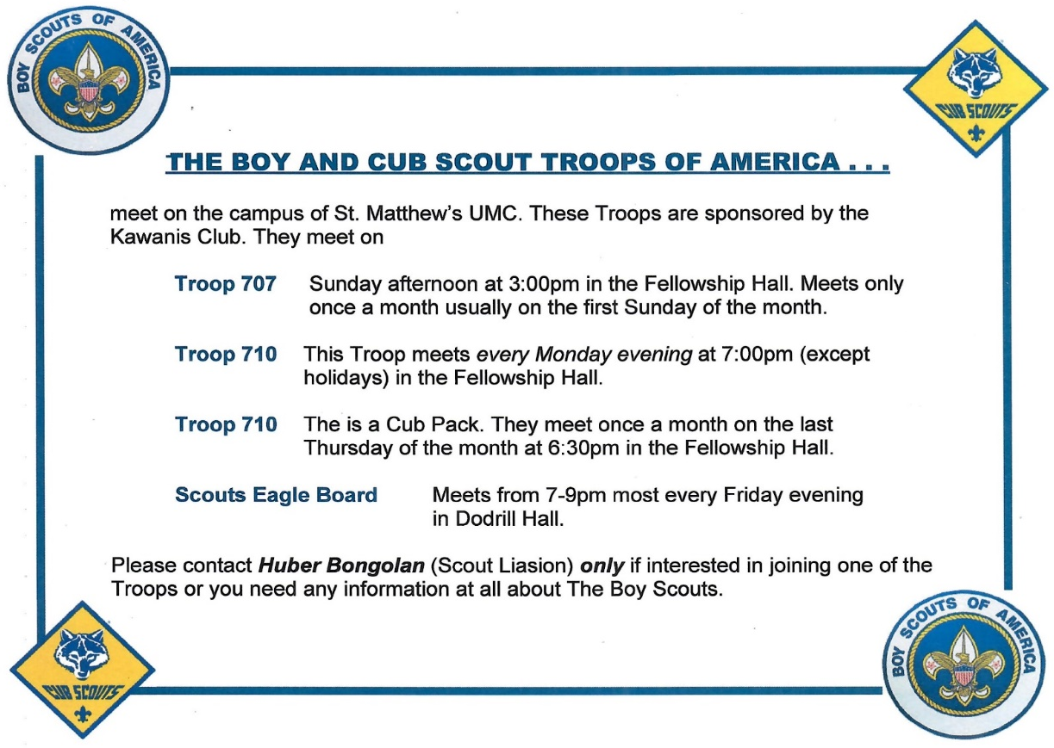



St. Mathew’s United Methodist Church
15653 Newton Street, Hacienda Heights, CA 91745
626-333-6656 smumchh@gmail.com www.stmattsumc.com
Office Hours: Monday - Thursday 9:30am to 3:30pm

